Catherine Moez

Nov. 27, 2020

**Pip Installation for Windows – Corrected Instructions**

**Official Pip installation instructions:** <https://pip.pypa.io/en/stable/installing/>), (<https://bootstrap.pypa.io/get-pip.py>).

**Problems:**

1. Doesn’t specify where to type the commands
2. Doesn’t specify the environment variables editing step
3. Content of the commands is wrong

**Error messages you may receive if running the commands in Python (Python shell) or in the Windows console shell (“Command Prompt”):**

'python' is not recognized as an internal or external command, operable program or batch file.; 'python3' is not recognized as an internal or external command, operable program or batch file.;

'pip' is not recognized as an internal or external command, operable program or batch file.;

“NameError: name 'get' is not defined”

“SyntaxError: unexpected character after line continuation character;

“SyntaxError: invalid syntax”.

**Solutions:**

First, download Python from python.org. From this point on,

1. **All commands are typed in the Windows console shell (“Command Prompt” program).**  
   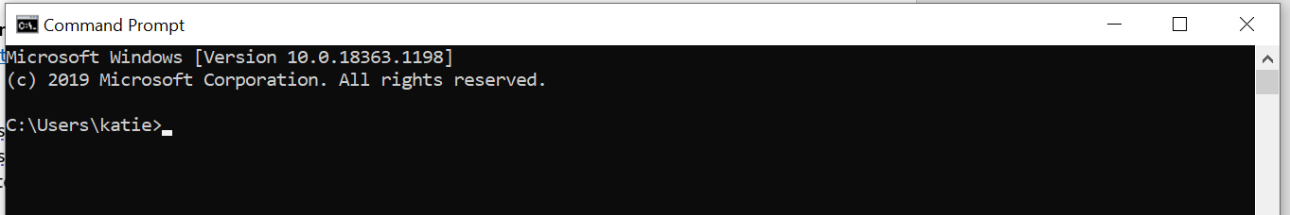
2. **System ‘Environment Variables’ must then be edited to add the file pathway to Python.**(2a.)Find the pathway to Python by right-clicking the Python program and looking at Properties. Copy the file pathway.

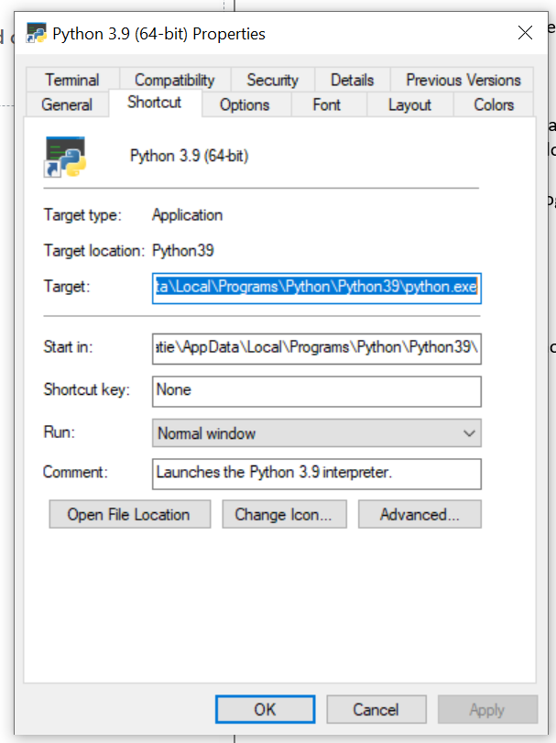

e.g. mine is:

C:\Users\katie\AppData\Local\Programs\Python\Python39

(2b) Add this pathway to your system’s **Environment Variables**.

Go to Control Panel > ... > Advanced System Settings > “Environment Variables..”, or search for it and click on this button.

Click “Path” and “Edit”, then add a new environment variable that is the file pathway you copied. (I also moved it to the top of the list – not sure if necessary).

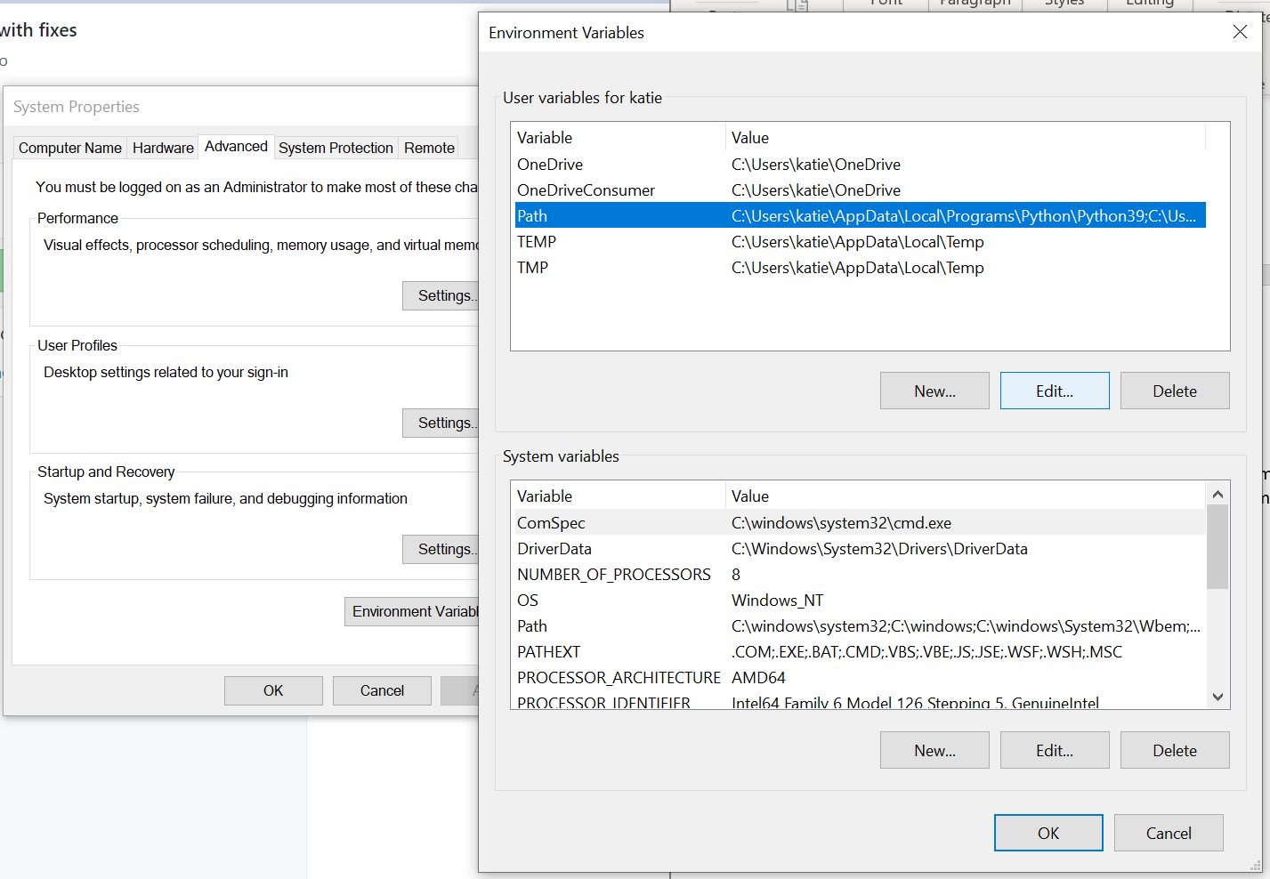

After entering the pathway to Python:

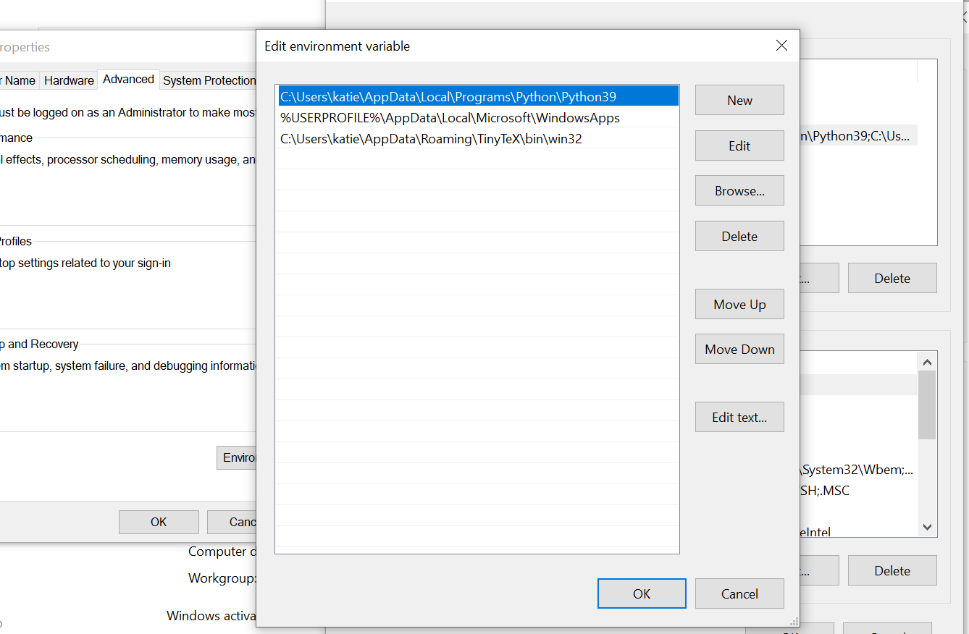

Click OK on all windows.

You can then call Python from the command shell:

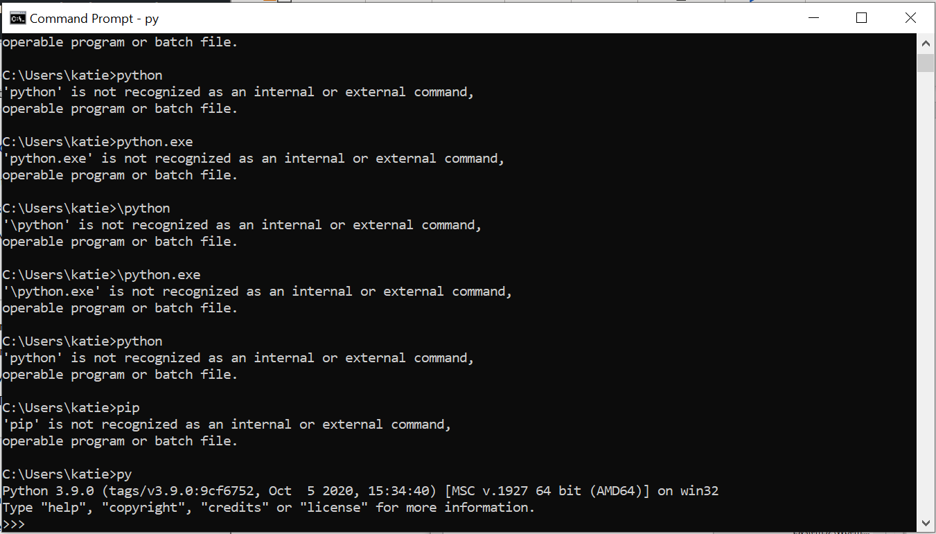

*Note that only the last line where I called ‘py’ worked. Not “python” or “python3”.

(credit: <https://stackoverflow.com/questions/17953124/python-is-not-recognized-as-an-internal-or-external-command>)

1. **Calling Pip from the command shell**

(3a) Make sure you have the Pip script.

It is installed automatically with later versions of Python, but you will have to specify the location. You should see a file named “pip” in the Scripts folder within your Python folder.

Copy the pathway to the folder containing the “pip” file.

e.g. for me:

C:\Users\katie\AppData\Local\Programs\Python\Python39\Scripts

**(3b) Close and restart the Windows shell (Command Prompt)** if you have already called Python with ‘py’. This will allow you to reset the working directory.

Set the working directory in the command shell to the Scripts folder with ‘cd’ + the pathway:

e.g. for me (I type everything after the ‘>’ exactly as written, in the command shell):

>cd C:\Users\katie\AppData\Local\Programs\Python\Python39\Scripts

I can then type “pip” in the shell:

>pip

To view a summary of the pip package:

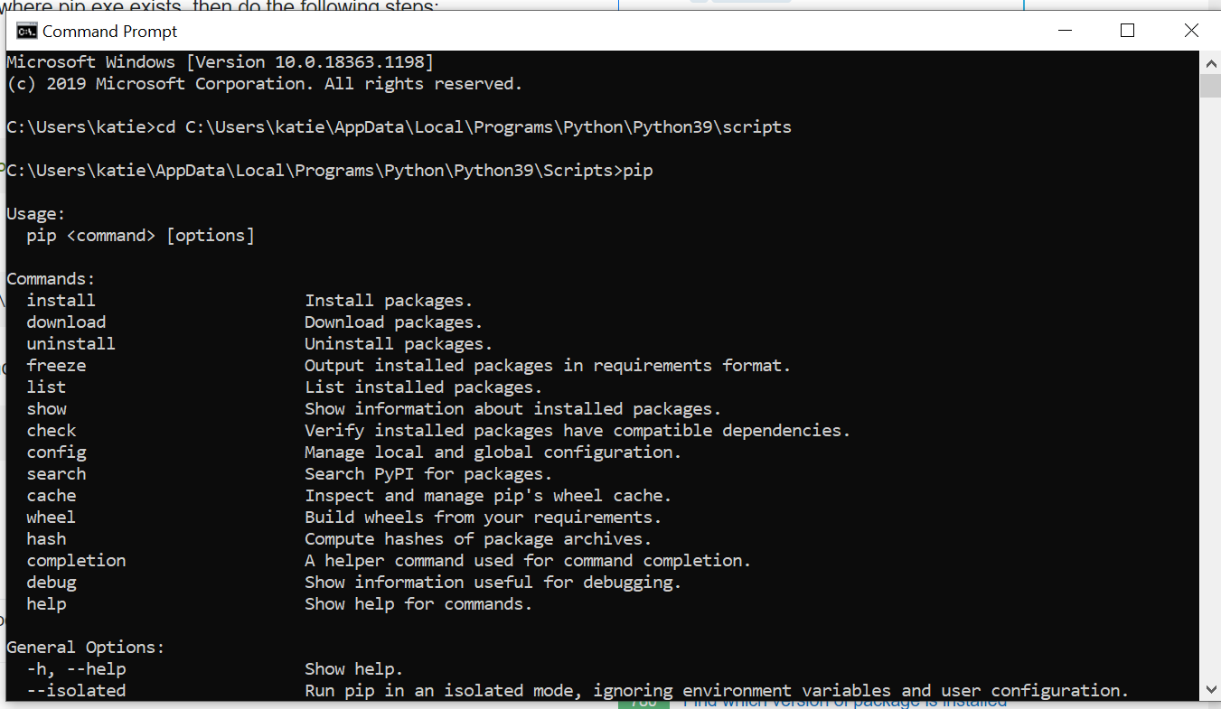

(credit: <https://stackoverflow.com/questions/47632891/pip-install-returning-invalid-syntax?rq=1>)

**(3c). I can then install Jupyter Notebook** by typing:

>pip install notebook

in the Command shell.

Result:

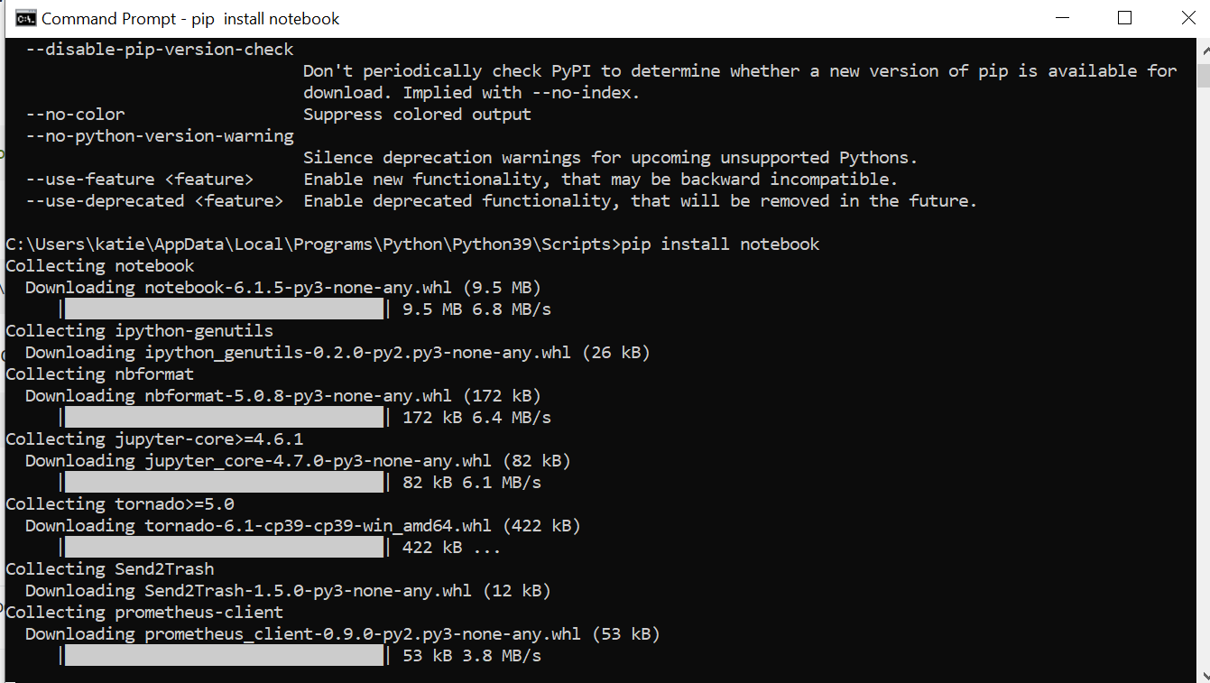

This will download and install **Jupyter Notebook** in the Scripts folder. You can then use the program. (either type “jupyter notebook” in the shell or click through your files for it).

*Note that Jupyter Notebook will be downloaded to the Scripts folder; you may want to move it.

**4. Getting started with Jupyter Notebook**

I have moved the jupyter notebook program file to Documents:



And then can save my Jupyter Notebook files to folders in Documents, using “Save as” and setting the folder location relative to where the Jupyter Notebook program is stored.

e.g.

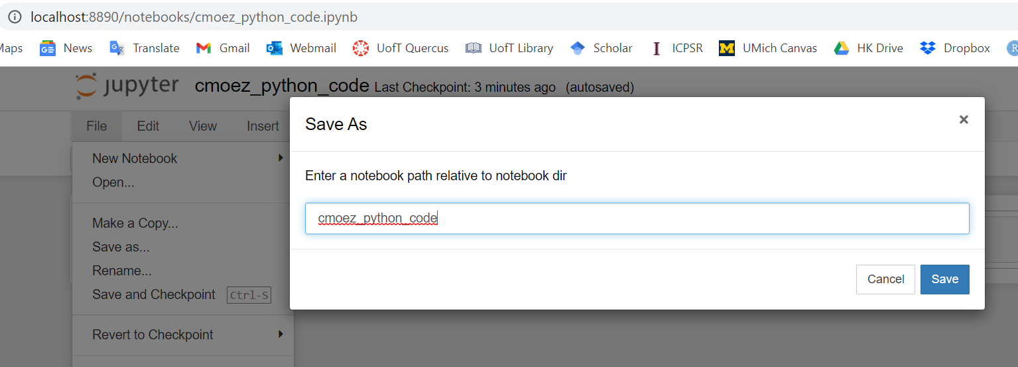

(“cmoez_python_code” being a folder in my Documents folder).

The file itself will open in Chrome and be .ipnyb format:

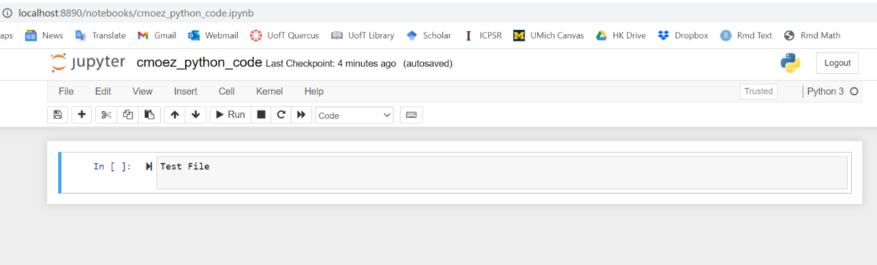

Installation complete 😊